3.2 Use case diagrams.

* Signup and login.

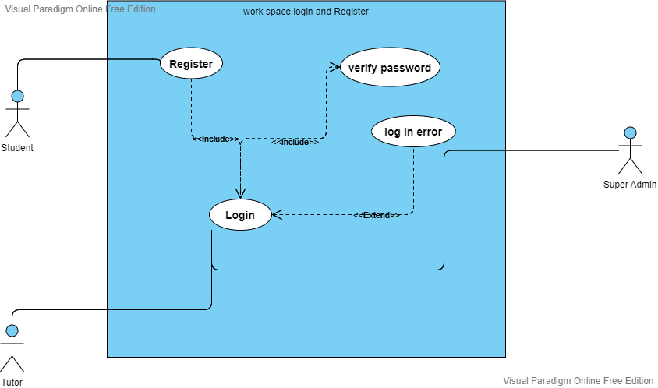

Usecase digram 3

|  |  |  |
| --- | --- | --- |
| Use Case ID: | CS1 | |
| Use Case Name: | Sign up | |
| Actors: | Unlogged in Client, user, System | |
| Pre-conditions: | Phone number & email used to register for any account type (Client, user), hasn’t been previously used | |
| Post-conditions: | If the use case was successful, the client is now registered into the system.  If not, the system state remains unchanged and send error message. | |
| Flow of events: | User Action | System Action |
| 1- Client Enter First Name, Last  Name, Email address, Phone number and Password. |  |
|  | 2- System stores data in  database |
| Exceptions: | User Action | System Action |
| 1- Client Enter First Name, Last  Name, Email address, Phone number and Password. |  |
|  | 1. Phone number, Email address or password is invalid. 2. System rejects sign up   applications |
| Priority | High | |
| Notes and  Issues: | Email address must be unique.  Password must contain only letters and numbers. | |

|  |  |  |
| --- | --- | --- |
| Use Case ID: | ULI1 | |
| Use Case Name: | Login | |
| Actors: | Unlogged in place owner, unlogged in user , system | |
| Pre-conditions: | User has already registered for an account | |
| Post-conditions: | If the use case was successful, the client and place owner is now  Logged into the system. | |
| Flow of events: | User Action | System Action |
| 1- User Enter Email address and  Password. |  |
|  | 2- System Verify user data |
| Exceptions: | User Action | System Action |
| 1- User Enter Email address and  Password. |  |
|  | 1. Email is invalid and unreadable or password does not correct. 2. System rejects login   application |
| Priority: | High | |
| Notes and  Issues: | Email must be registered in database.  Password must be the same as the registered password. | |

|  |  |  |
| --- | --- | --- |
| Use Case ID: | ULI1 | |
| Use Case Name: | Login to account (incorrect email/password combination) | |
| Actors: | Unlogged in Client, unlogged in place owner, system | |
| Pre-conditions: | User has already registered for an account | |
| Post-conditions: | If the use case was successful, the client and place owner is now  Logged into the system. | |
| Flow of events: | User Action | System Action |
| 1- User Enter Email address and  Password. |  |
|  | 2- System Verify user data |
| Exceptions: | User Action | System Action |
| 1- User Enter Email address and  Password. |  |
|  | 1. existing account but Email is invalid e or password does not correct. 2. System rejects login   Application with Please try again |
| Priority: | High | |
| Notes and  Issues: | Email must be registered in database.  Password must be the same as the registered password. | |

|  |  |  |
| --- | --- | --- |
| Use Case ID: | CS1 | |
| Use Case Name: | Forgot my password | |
| Actors: | Unlogged in Client, user, System | |
| Pre-conditions: | User has already registered for an account | |
| Post-conditions: | User account’s password is permanently changed with the new password entered.  user is logged in to their account and will be re-directed to homepage | |
| Flow of events: | User Action | System Action |
| 1. Client clicks on the “Forgot My Password” link under the login form 2. Enter your email address to receive a reset password |  |
|  | 3- re-directed to mobile application, where they view reset password  form  4- Client enters a new password & re-enters new password |
| Exceptions: |  |  |
|  |  | |
| Priority | High | |
| Notes and  Issues: | Email address must be unique.  Password must contain only letters and numbers. | |

* Search and booking use case

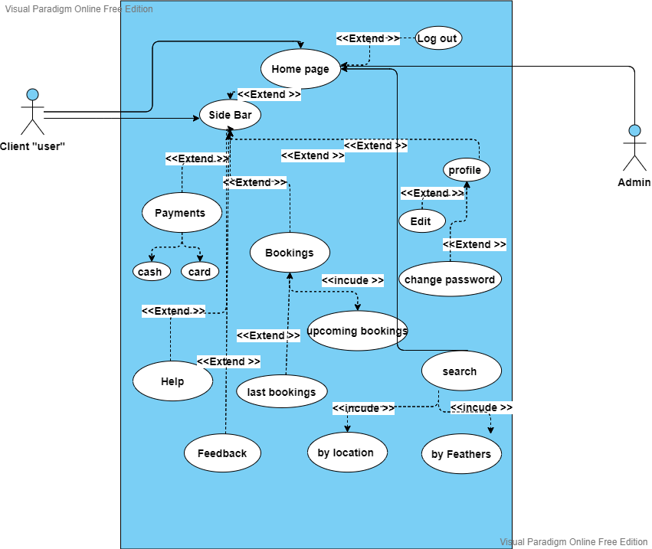

Usecase digram 4

|  |  |
| --- | --- |
| Use Case ID: | FG1 |
| Use Case Name: | Filter workspaces |
| Actors: | System |
| Pre-conditions: | None |
| Post-conditions: | If the use case was successful, the use case will return a filtered and sorted list of workspaces. If not, the system state remains  Unchanged. |
| Flow of events: | System Action |
| 1. the use case takes input from the system and prepares it for feed forwarding. 2. then it injects the input into the system’s filtering/sorting algorithm for computation. 3. the use case then returns a list of filtered and sorted workspaces to be represented to the client |
| Priority | High |

|  |  |  |
| --- | --- | --- |
| Use Case ID: | SDL1 | |
| Use Case Name: | Search Desired Location | |
| Actors: | logged in Client, system | |
| Pre-conditions: | Allowing access to location services | |
| Post-conditions: | If the use case was successful, the User will be prompted with a window to choose a workspace  If not, the system state remains unchanged. | |
| Flow of events: | User Action | System Action |
| 1-Client allow access to location  Services |  |
|  | 2- System uses (RM1) and  displays a map of Client current location |
| 3- Enter coordinates of desired  Location |  |
|  | 4- System Validate user Entries |
| Exceptions: | User Action | System Action |
| 1- Client allow access to location services and Enter coordinates  of desired location |  |
|  | 1. location services access not allowed or coordinates 2. System rejects Search   application |
| Priority: | High | |
| Notes and  Issues: | Coordinates must be in right format or known keyword. | |

|  |  |  |  |
| --- | --- | --- | --- |
| Use Case ID: | CWV1 | | |
| Use Case Name: | Choose which workspace | | |
| Actors: | logged in Client, system | | |
| Pre-conditions: | SDL1 | | |
| Post-conditions: | If the use case was successful, the User will be prompted to workspaces nearby his/her desired location  If not, the system state remains unchanged. | | |
| Flow of events:  Exceptions: | User Action | System Action | |
|  | 1-System pulls Client data from Database and displays all workspaces with Client options to choose from it. | |
| 2- Client Chooses which workspaces he/she will be using |  | |
|  | 3- system takes client input | |
| User Action | System Action | |
|  | 1-System displays Client workspaces to choose from.t | |
| 2- Client Chooses which workspaces he/she will be booking at |  | |
|  | 1. if client chooses to exit the booking process 2. System goes back to Home   Page | |
| Priority: | High | |
| Notes and  Issues: | Client must choose the room in workspaces he/she will be using. | |

|  |  |  |
| --- | --- | --- |
| Use Case ID: | VSS1 | |
| Use Case Name: | View and select suitable room in workspace | |
| Actors: | logged in Client, system | |
| Pre-conditions: | CWV1 | |
| Post-conditions: | If the use case was successful, the User will be prompted with a window to select start time  If not, the system state remains unchanged. | |
| Flow of events: | User Action | System Action |
|  | 1-System uses (google maps API) and displays a map of workspaces surrounding the destination. |
| 2- Client Chooses which workspace to review. |  |
|  | 3-System pulls workspace room  Information form database and display it to user. |
|  | 4-Client choose the room in workspace. |  |
| Exceptions: | User Action | System Action |
|  | 1-System uses (google maps API) and  displays a map of garages surrounding the destination |
| 2- Client Chooses which room in workspace to review. |  |
|  | 3-System pulls workspace room  Information form database and display it to user. |
|  | 4- Client chooses to go back and |  |

|  |  |  |
| --- | --- | --- |
| Use Case ID: | SST1 | |
| Use Case Name: | Select Start Time | |
| Actors: | logged in Client, system | |
| Pre-conditions: | VSS1 | |
| Post-conditions: | If the use case was successful and workspace charges daily Client will be prompted with a window to enter Payment information, else if workspace charges Hourly client will be prompted with a window to select start time  If not, the system state remains unchanged. | |
| Flow of events: | User Action | System Action |
|  | 1-System prompts user with a  windows to Select Start Time |
| 2- Client Chooses Start Time |  |
|  | 3-if workspace charges daily process will go to (EPI1), else if workspace charges hourly process will continue to (SET2) |
| Exceptions: | User Action | System Action |
|  | 1-System prompts user with a  windows to Select Start Time |
| 2- Client Chooses to go back and  select another workspace |  |
|  | 3-System goes back to (VSS1) |
| Priority: | High | |
| Notes and  Issues: | Client must select start time | |

|  |  |  |
| --- | --- | --- |
| Use Case ID: | SET2 | |
| Use Case Name: | Select End Time | |
| Actors: | logged in Client, system | |
| Pre-conditions: | SST1 | |
| Post-conditions: | If the use case was successful Client will be prompted with a receipt | |
|  | page  If not, the system state remains unchanged. | |
| Flow of events: | User Action | System Action |
|  | 1-System prompts user with a  windows to Select End Time |
| 2- Client Chooses End Time |  |
|  | 3-System will continue to (SET2) |
| Exceptions: | User Action | System Action |
|  | 1-System prompts user with a  windows to Select End Time |
| 2- Client Chooses to go back and  select another workspace |  |
|  | 3-System goes back to (VSS1) |
| Priority: | High | |
| Notes and  Issues: | Client must select End time. | |

|  |  |  |
| --- | --- | --- |
| Use Case ID: | EPI1 | |
| Use Case Name: | Enter Payment Information | |
| Actors: | logged in Client, system | |
| Pre-conditions: | SET2||SST1 | |
| Post-conditions: | If the use case was successful Client will be prompted with a Confirmation Page, System state changes to (booked room)  If not, the system state remains unchanged. | |
| Flow of events: | User Action | System Action |
|  | 1-System prompts user with a  Receipt Page |
| 2- Client clicks confirm |  |
|  | 3-System open a screen for user to Enter Credit Card  information |
|  | 4-Client Enters Credit Card number, expiration date, CCV  and Card Holder Name |  |
|  |  | 1. System validates Credit Card information 2. System prompts user with a   confirmation message |
|  | 7-Client clicks continue |  |

* User home page with sidebar options

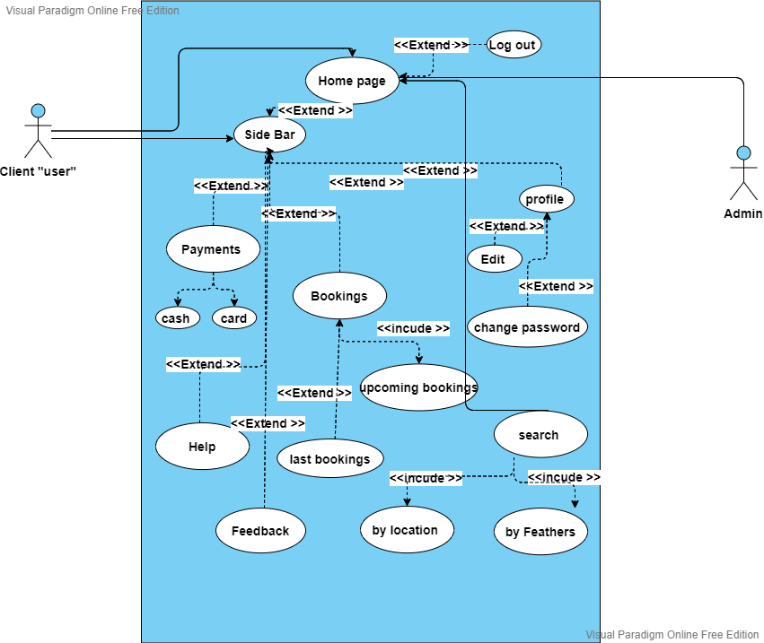

Usecase digram 5

|  |  |  |  |
| --- | --- | --- | --- |
| Use Case ID: | CHP1 | | |
| Use Case Name: | Home Page | | |
| Actors: | logged in Client, system | | |
| Pre-conditions: | ULI1 | | |
| Flow of events: | User Action | System Action | |
|  | 1-System request a map (RM1) using client’s current location and opens a page with a map of Client current location and an input field to search for desired  location (SDL1) | |
| 2- Client Enters desired location  to start booking process |  | |
|  | 3-System triggers (SDL1) | |
| Exceptions: | User Action | System Action | |
|  |  | 1-System request a map (RM1) using client’s current location and opens a page with a map of Client current location and an input field to search for desired  location (SDL1) | |
|  | 2-client choose to go sidebar |  | |
|  |  | 3-System redirects Garage  Owner to (US1) | |
| Priority: | Mediums | |

|  |  |  |
| --- | --- | --- |
| Use Case ID: | CSB1 | |
| Use Case Name: | Side Bar | |
| Actors: | logged in Client, system | |
| Pre-conditions: | CHP1 | |
| Post-conditions: | If the use case was successful Client will be redirected to his/her choice, if not the system state remains unchanged. | |
| Flow of events: | User Action | System Action |
|  | 1-System prompts Client with a sidebar containing Profile Page (UPP1), Home Page(CHP1), Booking, Help Center(UHC1), About us(UAU1) and Settings(US1) , payment , log out to choose  from |
| 2- Client Chooses an option |  |
|  | 3-System redirects Client to desired choice (use case). |
| Exceptions: | User Action | System Action |
|  | 1-System prompts Client with a sidebar containing Profile Page (UPP1), Home Page (CHP1), Booking, , Help Center(UHC1), About us(UAU1) and Settings(US1) , payment , log out to choose  from |
| 2- Client Chooses to close  Sidebar |  |
|  | 3-System goes back to (CHP1) |
| Priority: | High | |

|  |  |  |
| --- | --- | --- |
| Use Case ID: | CR1 | |
| Use Case Name: | Reservation (Booking) | |
| Actors: | logged in Client, system | |
| Pre-conditions: | CSB1 | |
| Post-conditions: | If the use case was successful Client will be redirected to his/her choice, if not the system state remains unchanged. | |
| Flow of events: | User Action | System Action |
|  | 1-System prompts Client with a Page containing all of his/her past reservation and if a reservation is still in progress, he/she will be prompted with a  navigate button |
| 2- Client reviews reservation and chooses to navigate future  Reservation |  |
|  | 3-System request a route (RM1) from GPS API using client’s current location and desired location and prompts user with a navigation map (NM1) |
| Exceptions: | User Action | System Action |
|  | 1-System prompts Client with a Page containing all of his/her past reservation and if a reservation is still in progress, he/she will be prompted with a  navigate button |
| 2- Client Chooses to go back |  |
|  | 3-System goes back to (CSB1) |
| Priority: | High | |
| Notes and  Issues: | User must have already given access to the location settings. | |

|  |  |  |
| --- | --- | --- |
| Use Case ID: | CRV1 | |
| Use Case Name: | Past bookings | |
| Actors: | logged in Client, system | |
| Pre-conditions: | CSB1 | |
| Post-conditions: | If the use case was successful Client will be redirected to his/her registered past bookings table, if not the system state remains unchanged. | |
| Flow of events: | User Action | System Action |
|  | 1-System prompts Client with a Page containing all his/her reserved Past bookings with a button to each workspace room used |
| 2- Client reviews reserved  room and chooses action to be done |  |
|  | 3-System retrieve the data to user |
| Exceptions: | User Action | System Action |
|  | 1-System prompts Client with a Page containing all his/her reserved Past bookings with a button to each workspace room used |
| 2- Client Chooses to go back |  |
|  | 3-System goes back to (CSB1) |
| Priority: | Medium | |

|  |  |  |
| --- | --- | --- |
| Use Case ID: | CRV1 | |
| Use Case Name: | Upcoming bookings | |
| Actors: | logged in Client, system | |
| Pre-conditions: | CSB1 | |
| Post-conditions: | If the use case was successful Client will be redirected to his/her registered vehicle’s table, if not the system state remains unchanged. | |
| Flow of events: | User Action | System Action |
|  | 1-System prompts Client with a Page containing all of his/her Upcoming reservations with a button to each workspace |
| 2- Client reviews Upcoming reservations and chooses action to be done |  |
|  | 3-System triggers desired use case (CRV2 || CAV1) |
| Exceptions: | User Action | System Action |
|  | 1-System prompts Client with a Page containing all of his/her Upcoming reservations with a button to each workspace |
| 2- Client Chooses to go back |  |
|  | 3-System goes back to (CSB1) |
| Priority: | Medium | |

|  |  |  |  |
| --- | --- | --- | --- |
| Use Case ID: | UAU1 | | |
| Use Case Name: | About Us | | |
| Actors: | (Logged in workspace Owner || logged in user), system | | |
| Pre-conditions: | GSB1 || CSB1 | | |
| Post-conditions: | If the use case was successful workspace Owner will be redirected to the application About Us Page.  , if not, the system state remains unchanged. | | |
| Flow of events: | User Action | System Action | |
|  | 1-System opens a window containing brief paragraphs (our scope- our purpose – Contact E-  mail) | |
|  | 2- user views information and  chooses to go back |  | |
|  | 3-System goes back go  (GHP1) ||() | |
| Priority: | Low |
| Notes and  Issues: | None |
| Use Case ID: | UHC1 | | |
| Use Case Name: | terms of service | | |
| Actors: | (Logged in space Owner || logged in Client), system | | |
| Pre-conditions: | GSB1 || CSB1 | | |
| Post-conditions: | If the use case was successful Workspace Owner will be redirected to the application Help Center.  , if not, the system state remains unchanged. | | |
| Flow of events: | User Action | System Action | | |
|  | 1-System opens a window  containing a series term of service | | |
| 2- user scroll to read the service we present and rules |  | | |
| Exceptions: | **User Action** | **System Action** | | |
|  | 1-System opens a window  containing a series term of service |
| 2- user chooses to go back |  | | |
|  | 3-System redirects to  (GHP1) || () | | |
| Priority: | Low | | |
| Notes and  Issues: | None | | |

|  |  |  |
| --- | --- | --- |
| Use Case ID: | UHC1 | |
| Use Case Name: | Feedback | |
| Actors: | (Logged in space Owner || logged in Client), system | |
| Pre-conditions: | GSB1 || CSB1 | |
| Post-conditions: | If the use case was successful space Owner will be redirected to the application to rate the application on google play.  , if not, the system state remains unchanged. | |
| Flow of events: | User Action | System Action |
|  | 1-System redirect the user to rate our application on google play app |
| 2- user give his opinion about the app and give stars for rating |  |
|  |  |
| Exceptions: | User Action | System Action |
|  | 1-System redirect the user to rate our application on google play app |
| 2- user chooses to go back |  |
|  | 3-System redirects user to  (GHP1) |
| Priority: | Low | |
| Notes and  Issues: | None | |

* Admin and system admin portal use cases. 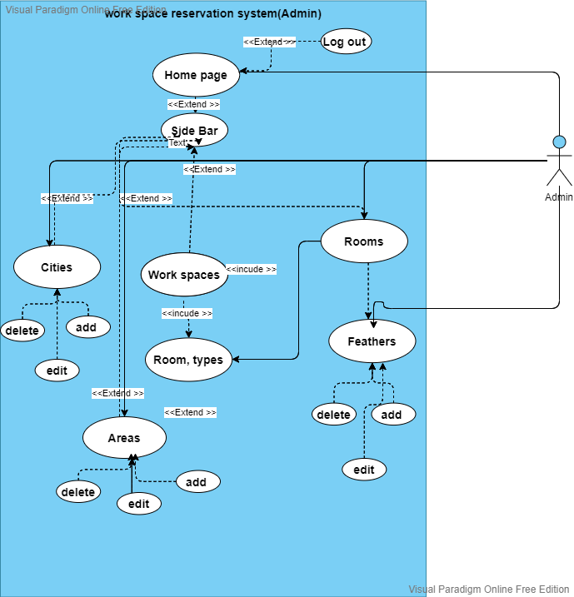

Usecase digram 6

|  |  |  |
| --- | --- | --- |
| Use Case ID: | ULI1 | |
| Use Case Name: | Login | |
| Actors: | Unlogged in Client, unlogged in place owner, system | |
| Pre-conditions: | User has already registered for an account | |
| Post-conditions: | If the use case was successful, the client and place owner is now  Logged into the system. | |
| Flow of events: | **User Action** | System Action |
| 1- User Enter Email address and  Password. |  |
|  | 2- System Verify user data |
| Exceptions: | User Action | System Action |
| 1- User Enter Email address and  Password. |  |
|  | 2-Email is invalid and unreadable or password does not correct.  3-System rejects login  Application |
| Priority: | High | |
| Notes and  Issues: | Email must be registered in database.  Password must be the same as the registered password. | |

|  |  |  |
| --- | --- | --- |
| Use Case ID: | VR1 | |
| Use Case Name: | View workspaces requests | |
| Actors: | logged in Admin, system | |
| Pre-conditions: | Admin has already logged in | |
| Post-conditions: | Admin views all workspace requests that were submitted by workspace owners as they create new workspace through the web dashboard application them view details when open the request | |
| Flow of events: | User Action | System Action |
| 1- admin enter requests page |  |
|  | 2- System retrieve all requests with bottom to show the request information |
| Exceptions: | User Action | System Action |
| 1- admin enter requests page |  |
|  | 2- not have any requests to retrieve or admin back to dashboard |
| Priority: | High | |
| Notes and  Issues: |  | |

|  |  |  |
| --- | --- | --- |
| Use Case ID: | AVR1 | |
| Use Case Name: | Approve a new workspace request | |
| Actors: | logged in Admin, system | |
| Pre-conditions: | Admin has already logged in | |
| Post-conditions: | Admin after viewing all workspace request information that were submitted by workspace owners, they approve the add request or refuse it with explanation | |
| Flow of events: | User Action | System Action |
| 1- admin enter requests page |  |
|  | 2- System retrieve all requests with bottom to show the request information |
|  | 3- admin approve the request or refuse it with explanation |  |
| Exceptions: | User Action | System Action |
| 1- admin enter requests page |  |
|  | 2- not have any requests to retrieve or admin back to dashboard |
| Priority: | High | |
| Notes and  Issues: |  | |
| Use Case ID: | AVR1 | |
| Use Case Name: | Block and unblock an owner | |
| Actors: | logged in Admin, system | |
| Pre-conditions: | already have registered workspace in system | |
| Post-conditions: | Admin view workspace owners an could Block and Unblock them to use the system or not | |
| Flow of events: | User Action | System Action |
| 1- admin enter workspace owner’s page |  |
|  | 2- System retrieve all owners details to deleted or block or to unblock owner |
|  | 3- admin send explanation of blocking |  |
| Exceptions: | User Action | System Action |
| 1- admin enter workspace owner’s page |  |
|  | 2- System retrieve all owners details to deleted or block or to unblock owner  3-back to home with no action |
| Priority: | High | |
| Notes and  Issues: |  | |

|  |  |  |
| --- | --- | --- |
| Use Case ID: | VR1 | |
| Use Case Name: | View and manage workspaces | |
| Actors: | logged in Admin, system | |
| Pre-conditions: | Admin has already logged in and there is workspaces to managed | |
| Post-conditions: | Admin views all workspaces in the system that were submitted by workspace owners. admin could select and view a specific one | |
| Flow of events: | User Action | System Action |
| 1- admin enter workspaces page |  |
|  | 2- System retrieve all workspaces with bottom to show the information, delete , update ,add ,search for each workspace |
|  | 3-admin choose which operation he wants to do |  |
| Exceptions: | User Action | System Action |
| 1- admin enter workspaces page |  |
|  | 2- System retrieve all workspaces with bottom to show the information, delete, update, add, search for each workspace  3-admin go to home page without any action |
| Priority: | High | |
| Notes and  Issues: |  | |

|  |  |  |
| --- | --- | --- |
| Use Case ID: | VR1 | |
| Use Case Name: | View and manage owners | |
| Actors: | logged in Admin, system | |
| Pre-conditions: | Admin has already logged in and there are workspaces to managed | |
| Post-conditions: | Admin views all owners in the system that were submitted by workspace owners, admin could select and view a specific one | |
| Flow of events: | User Action | System Action |
| 1- admin enter owner’s page |  |
|  | 2- System retrieve all owners with bottom to show the information, delete, update, add, search for each owner  3-admin could block and unblock them |
|  | 4-admin choose which operation he wants to do |  |
| Exceptions: | User Action | System Action |
| 1- admin enter owner’s page |  |
|  | 2- System retrieve all owners with bottom to show the information, delete, update, add, search for each workspace  3-admin go to home page without any action |
| Priority: | High | |
| Notes and  Issues: |  | |

|  |  |  |
| --- | --- | --- |
| Use Case ID: | VMR1 | |
| Use Case Name: | View and manage workspace rooms | |
| Actors: | logged in Admin, system | |
| Pre-conditions: | Admin has already logged in and there are workspaces to managed | |
| Post-conditions: | Admin views all workspace rooms in the system that were submitted by workspace owners, admin could select and view a specific one | |
| Flow of events: | User Action | System Action |
| 1- admin enter work pace rooms page |  |
|  | 2- System retrieve all rooms with bottom to show the information, delete, update, add, search for each room  3-admin could update any info about it |
|  | 3-admin choose which operation he wants to do |  |
| Exceptions: | User Action | System Action |
| 1- admin enter owner’s page |  |
|  | 2- System retrieve all rooms with bottom to show the information, delete, update, add, search for each workspace rooms  3-admin go to home page without any action |
| Priority: | High | |
| Notes and  Issues: |  | |

|  |  |  |
| --- | --- | --- |
| Use Case ID: | VMR1 | |
| Use Case Name: | View and manage workspace rooms feathers | |
| Actors: | logged in Admin, system | |
| Pre-conditions: | Admin has already logged in and there is workspaces room to managed | |
| Post-conditions: | Admin views all workspace rooms in the system that were submitted by workspace owner’s admin could select and view a specific one | |
| Flow of events: | User Action | System Action |
| 1- admin enter work pace room page  2- then choose feathers |  |
|  | 3- System retrieve all room feathers in it with bottom to show the information, delete, update, add, room feathers for managing it  4-admin could update any info about it |
|  | 3-admin choose which operation he wants to be done  4- then back to home or room after editing |  |
| Exceptions: | User Action | System Action |
| 1- admin enter work pace room page  2- then choose feathers |  |
|  | 3- System retrieve all room feathers in it with bottom to show the information , delete , update ,add ,room feathers for managing it  4-admin back without nothing |
| Priority: | High | |
| Notes and  Issues: |  | |

|  |  |  |
| --- | --- | --- |
| Use Case ID: | VMR1 | |
| Use Case Name: | View and manage workspace room types | |
| Actors: | logged in Admin, system | |
| Pre-conditions: | Admin has already logged in and there is workspaces to managed | |
| Post-conditions: | Admin could add new types of rooms to system or delete one | |
| Flow of events: | User Action | System Action |
| 1- admin enter room types of pages |  |
|  | 2- System retrieve all rooms type with bottom to show the information, delete, update, add, search for each room type  3-admin could update any info about it |
|  | 4-admin choose which operation he wants to be done |  |
| Exceptions: | User Action | System Action |
| 1- admin enter owner’s page |  |
|  | 2- System retrieve all rooms type with bottom to show the information, delete, update, add, search for each workspace rooms  3-admin go to home page without any action |
| Priority: | High | |
| Notes and  Issues: |  | |

|  |  |  |
| --- | --- | --- |
| Use Case ID: | VMR1 | |
| Use Case Name: | View and manage cities | |
| Actors: | logged in Admin, system | |
| Pre-conditions: | Admin has already logged in and there are workspaces to managed | |
| Post-conditions: | Admin could add new cities to system, update also delete | |
| Flow of events: | User Action | System Action |
| 1- admin enter room types of pages |  |
|  | 2- System retrieve all rooms type with bottom to show the information, delete, update, add, search for each room type  3-admin could update any info about it |
|  | 4-admin choose which operation he wants to be done |  |
| Exceptions: | User Action | System Action |
| 1- admin enter owner’s page |  |
|  | 2- System retrieve all rooms type with bottom to show the information, delete, update, add, search for each workspace rooms  3-admin go to home page without any action |
| Priority: | High | |
| Notes and  Issues: |  | |

|  |  |  |
| --- | --- | --- |
| Use Case ID: | VMR1 | |
| Use Case Name: | View and manage areas | |
| Actors: | logged in Admin, system | |
| Pre-conditions: | Admin has already logged in and there are workspaces to managed | |
| Post-conditions: | Admin could add new areas to system, update also delete | |
| Flow of events: | User Action | System Action |
| 1- admin enter room types of pages |  |
|  | 2- System retrieve all rooms type with bottom to show the information, delete, update, add, search for each room type  3-admin could update any info about it |
|  | 4-admin choose which operation he wants to be done |  |
| Exceptions: | User Action | System Action |
| 1- admin enter owner’s page |  |
|  | 2- System retrieve all rooms type with bottom to show the information, delete, update, add, search for each workspace rooms  3-admin go to home page without any action |
| Priority: | High | |
| Notes and  Issues: |  | |

Logged on workspace’s owner use cases.

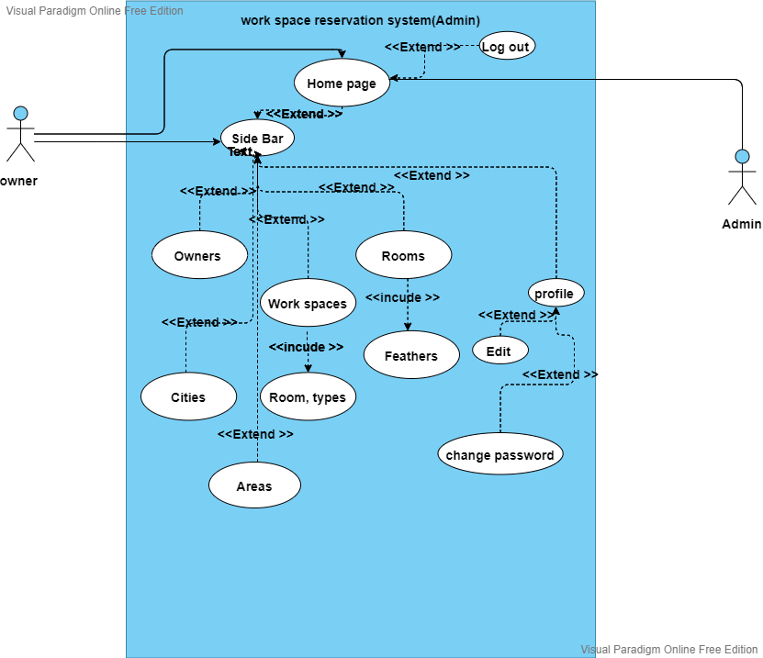

Usecase digram 7

|  |  |  |
| --- | --- | --- |
| Use Case ID: | GHP1 | |
| Use Case Name: | Home Page | |
| Actors: | logged in workspace Owner, system | |
| Pre-conditions: | None | |
| Post-conditions: | If the use case was successful workspace Owner will be prompted with the Home Page  , if not, the system state remains unchanged. | |
| Flow of events: | User Action | System Action |
|  | 1-System opens a Home Page for workspace Owner to review statistical data and ratings for the  Workspace to choose from |
| 2- Client Chooses rating to  Review  3 – or choose another option for his workspace |  |
|  | 1. System pulls review data from database 2. System displays Rating &   review for workspace Owner |
| Exceptions: | User Action | System Action |
|  | 1-System opens a Home Page for Workspace Owner to review statistical data and ratings for the  Workspace to choose from |
| 2- Client Chooses to open  Sidebar |  |
|  | 3-System goes to (GSB1) |
| Priority: | High | |
| Notes and  Issues: |  | |

|  |  |  |  |
| --- | --- | --- | --- |
| Use Case ID: | GSB1 | | |
| Use Case Name: | Side Bar | | |
| Actors: | logged in workspace Owner, system | | |
| Pre-conditions: | GHP1 | | |
| Post-conditions: | If the use case was successful workspace Owner will be redirected to his/her choice  , if not, the system state remains unchanged. | | |
| Flow of events: | **User Action** | System Action | |
|  | 1-System prompts workspace owner with a sidebar containing Profile Page (GPP1), Home Page(GHP1), workspace info(GGI1), workspace Vacancy(GGV1), Help Center(UHC1), About us(UAU1) and Settings(US1) to choose  from | |
| 2- workspace owner Chooses an  option |  | |
|  | 3-System redirects workspace Owner to desired choice (use case). | |
| Exceptions: | **User Action** | System Action | |
|  | 1-System prompts workspace owner with a sidebar containing Profile Page (GPP1), Home Page(GHP1), workspace info(GGI1), workspace Vacancy(GGV1), Help Center(UHC1), About us(UAU1) and Settings(US1) to choose  from | |
| 2- workspace owner Chooses to  close sidebar |  | |
|  | 3-System goes back to (GHP1) | |
| Priority: | High | |
| Notes and  Issues: |  | |

|  |  |  |
| --- | --- | --- |
| Use Case ID: | ULO1 | |
| Use Case Name: | Log Out | |
| Actors: | logged in workspace Owner, system | |
| Pre-conditions: | GPP1 | |
| Post-conditions: | If the use case was successful workspace Owner will be redirected to the Login page.  , if not, the system state remains unchanged. | |
| Flow of events: | **User Action** | System Action |
|  | 1. System Log user out 2. System redirects user to login page (ULI1) |
| Priority: | Medium | |
| Notes and  Issues: | None | |

|  |  |  |  |
| --- | --- | --- | --- |
| Use Case ID: | GGI1 | | |
| Use Case Name: | Workspace info | | |
| Actors: | logged in Workspace Owner, system | | |
| Pre-conditions: | GSB1 | | |
| Post-conditions: | If the use case was successful Workspace’s owner will be redirected to his\her Workspace info page || edit Workspace info page  , if not, the system state remains unchanged. | | |
| Flow of events: | User Action | System Action | |
|  | 1-System will open a window for Workspace owner view his/her Workspace information (photos,  Workspace name, capacity, | |
|  | 1-System will open a window for Workspace owner view his/her Workspace information (photos,  Workspace name, capacity, availability, pricing, address, working hours, contact numbers and numbers of rooms)  2-and a bottom to edit his/her  Workspace information | |
| 3- Workspace owner click on edit  Workspace info |  | |
| Exceptions: | User Action | System Action | |
|  | 1. System will open a window for Workspace owner view his/her Workspace information (photos, Workspace name, capacity, availability, pricing, address, working hours, contact numbers and number of floors) 2. and a bottom to edit his/her   Workspace information | |
| 3- Workspace views Workspace info and chooses to go back |  | |
| Priority: | High | |
| Notes and  Issues: | None | |

|  |  |  |  |
| --- | --- | --- | --- |
| use Case ID: | UPP1 | | |
| Use Case Name: | Profile Page | | |
| Actors: | (Logged in Garage Owner || logged in Client), system | | |
| Pre-conditions: | GSB1 || CSB1 | | |
| Post-conditions: | If the use case was successful User will be redirected to his/her Profile Page  , if not, the system state remains unchanged. | | |
| Flow of events: | User Action | System Action |
|  | 1. System pulls Garage owner information from Database and displays them in profile Page which contains of photo, Full name, Phone number, Email 2. and the system provides three options, Edit Profile (UEP1), Change password (UCP1) and   logout (ULO1) |
| 3- User Chooses an option |  |
|  | 4-System redirects User to desired choice (use case). |
| Exceptions: | User Action | System Action |
|  | 1. System pulls User information from Database and displays them in profile Page which contains of photo, Full name, Phone number, Email 2. and the system provides three options, Edit Profile (GEP1), Change password (GCP1) and   logout (ULO1) |
| 2- User Chooses to go back |  |
|  | 3-System goes back to (GHP1) |
| Priority: | High | |
| Notes and  Issues: |  | |

|  |  |  |  |
| --- | --- | --- | --- |
| Use Case ID: | UCP1 | | |
| Use Case Name: | Change Password | | |
| Actors: | (Logged in workspace Owner || logged in Client), system | | |
| Pre-conditions: | UPP1 | | |
| Post-conditions: | If the use case was successful user will be redirected to his\her profile page and the password is successfully changed.  , if not, the system state remains unchanged. | | |
| Flow of events: | User Action | System Action | |
|  | 1-System will open a window for user to Enter his current password. | |
| 1. User Enters current password. 2. user clicks Next |  | |
|  | 1. System verifies the entered password.   System opens a new window to enter his\her new password twice for confirmation. | |
| 1. User enters the new password twice. 2. User Clicks Save. |  | |
|  | 1. System checks if both entries are the same 2. System updates workspace owner password in database. | |
| Exceptions: | User Action | System Action | |
|  | 1-System will open a window for user to Enter his current password. | |
| 2- User Enters current password. 3- user clicks Next |  | |
|  | 5-Entered password is wrong. 6-System notify user that the  Entered password is wrong. | |
| 1. User Re-enters a different password. 2. user clicks save |  | |
|  | 9--System verifies the entered password.10-System open a new window to enter his\her new password twice for confirmation. | |
| 11- User enters a new password  Twice. |  | |
|  | 12-Both entries are not the same 13-System notify user that both  Passwords are not the same. | |
| Priority: | High | |
| Notes and  Issues: | User must enter a valid password and both new passwords must be  The same. | |

|  |  |  |  |
| --- | --- | --- | --- |
| Use Case ID: | UAU1 | | |
| Use Case Name: | About Us | | |
| Actors: | (Logged in workspace Owner || logged in Client), system | | |
| Pre-conditions: | GSB1 || CSB1 | | |
| Post-conditions: | If the use case was successful workspace Owner will be redirected to the application About Us Page.  , if not, the system state remains unchanged. | | |
| Flow of events: | **User Action** | System Action | |
|  | 1-System opens a window containing brief paragraphs (our scope- our purpose – Contact E-  mail) | |
| 2- user views information and  chooses to go back |  | |
|  | 3- user go back for home  () | |
| Priority: | Low | |
| Notes and  Issues: | None | |